FORMS
ADDENDUM TO DIVORCE INSTRUCTION PACKET

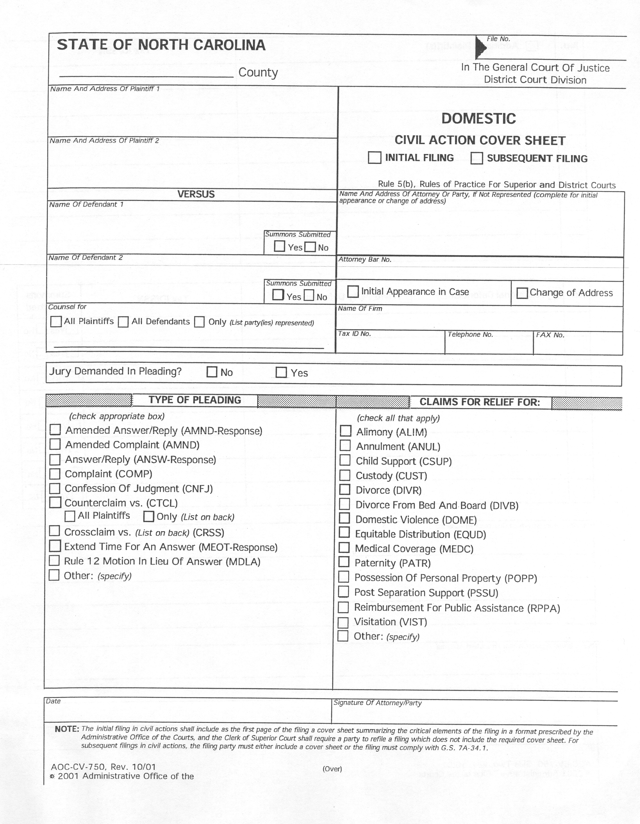

NORTH CAROLINA IN THE GENERAL COURT OF JUSTICE
DISTRICT COURT DIVISION
_____________________ COUNTY FILE NO.

___________________________________, )
Plaintiff, )
)
vs. )
) DIVORCE COMPLAINT
___________________________________, )
Defendant, )
)
)

The Plaintiff, complaining of the Defendant, alleges the following:

1. For the six months before filing this action, the Plaintiff has been a resident and citizen of North Carolina. The Plaintiff is a resident of __________________ County.

2. Upon information and belief, the Defendant is a citizen and resident of _____________ County, ____________ (state).

3. The Plaintiff and the Defendant were lawfully married to each other on or about _____________, ______ (date), in ________________ County, ________________ (state).

4. The Plaintiff and the Defendant separated from each other on ____________, ______. Since that date, they have lived continuously separate and apart and have not resumed their marital relationship.

5. The Plaintiff is entitled to an absolute divorce from the Defendant based upon separation for one year.

6. The names and ages of the minor children born of this marriage are as follows:
________________________________________________________________________________________________________________________________________________________________________________________________________________________________________________________________________________________________________________________

7. (Check box if applicable ) The Plaintiff requests an equitable distribution of the marital property under N.C. Gen. Stat. § 50-20.

8. (Check box if applicable ) The Plaintiff wishes to resume the use of the name, ______________________.

WHEREFORE, the Plaintiff respectfully asks the Court to grant the following relief:

1. Grant the Plaintiff an absolute divorce from the Defendant based on separation for one year.

2. (Check box if applicable ) Order that the Plaintiff's claim for equitable distribution be preserved and is pending.

3. (Check box if applicable ) Grant the Plaintiff the right to resume using the name, _________________________________.

4. Grant the Plaintiff such other and further relief as is just and proper.

Respectfully submitted,

Date:___________________ __________________________
Plaintiff's Signature
Plaintiff's Address:
__________________________
__________________________
__________________________

VERIFICATION

Being first duly sworn, I state that I am the Plaintiff in this action, I have read and signed this Divorce Complaint, and the information contained herein is true of my own knowledge, except as to those matters stated on information and belief, and as to those matters, I am informed and believe them to be true.

This the ___ day of ___________, 20 ___.

______________________________
Plaintiff's Signature

Subscribed and sworn to before me, this _____ day of __________ 20_____.

______________________________
NOTARY PUBLIC
My Commission Expires: ________

YOU MUST BRING TWO COPIES OF THE JUDGMENT AND ONE CERTIFICATE OF ABSOLUTE DIVORCE OR ANNULMENT WITH YOU TO YOUR HEARING!

NORTH CAROLINA IN THE GENERAL COURT OF JUSTICE
DISTRICT COURT DIVISION
________________ COUNTY FILE NO.

_________________________________________, )
Plaintiff, , )
)
vs. )
) JUDGMENT OF DIVORCE
_________________________________________, )
Defendant, )
)

THIS CAUSE coming on to be heard before the undersigned Judge Presiding at __________ County District Court on the filing of Plaintiff’s claim for an absolute divorce based on one year’s separation, and the Court having considered the verified Complaint and determined that Plaintiff is entitled to an absolute divorce as a matter of law, the Court makes the following:

FINDINGS OF FACT

1. This is an action for absolute divorce on the grounds of separation of the Plaintiff and the Defendant for one consecutive year.

2. The Defendant was properly served with a copy of the summons and complaint and has not filed a request for jury trial.

3. The Plaintiff has been a citizen and resident of North Carolina for at least six (6) months preceding the filing of this action

4. The Plaintiff and the Defendant were married on ____________________ and separated on or about ______________________, with the intent of ending their marital relationship and have lived separate and apart from each other since that date.

5. (Check box if applicable ) The Plaintiff has requested equitable distribution in the divorce complaint.

6. (Check box if applicable ) The plaintiff desires to resume use of the name,
________________________.
- The parties have _______ minor children. The names and ages of the minor children are as follows:
_______________________________________________________________________________________________________________________________________________________________________________________________.
OR
No children were born of the marriage.
OR
The children born of the marriage have all reached the age of majority.
Based on these finding of fact, the court concludes as a matter of law that the court has personal and subject matter jurisdiction of this matter and that Plaintiff is entitled to an absolute divorce.
IT IS THEREFORE, ORDERED ADJUDGED AND DECREED AS FOLLOWS:
1. The bonds of matrimony previously existing between the Plaintiff and the Defendant are wholly dissolved, and the Plaintiff is granted an absolute divorce from the Defendant.
2. (Check box if applicable ) This Judgment is limited to granting an absolute divorce, and the Plaintiff's claim for equitable distribution is reserved for hearing at a later time.

- (Check box if applicable ) The Plaintiff is allowed to resume use of the name,

_______________________________.

4. (Check box if applicable ) The Plaintiff shall bear the costs of this action.
This the ______ day of _________________ 20 ___ .

__________________________________
DISTRICT COURT JUDGE PRESIDING
NORTH CAROLINA IN THE GENERAL COURT OF JUSTICE
DISTRICT COURT DIVISION
________________ COUNTY FILE NO.

_________________________________________, )
Plaintiff, , )
)
vs. )
) Certificate of Service
_________________________________________, )
Defendant, )
)

This is to certify that the undersigned has this date served the Judgment of Divorce in the above entitled action upon Defendant by depositing a copy hereof in a postpaid envelope in a post office or official depository under the exclusive care and custody of the United States Post Office Department properly addressed to the defendant or attorney for the defendant as set out below.

______________________________________________________________________________
Defendant/Defendant’s Attorney’s Address or Last Known Address:

This the __________ day of ___________________, 20____.

By:
Plaintiff

Plaintiff’s Address and Phone Number.

HEARING SCRIPT
- My name is _______________________________.

- I have been a resident of North Carolina since _________________ (must be at least 6 months before filing your case).

- My spouse’s name is ________________________________.

- I got married on _____________________________ in _________________County _______________________ (State).

- I separated from my spouse on or about _______________________(date must be at least one year before filing your divorce action).

- My spouse and I have lived continuously separate and apart since that date.

- I want to resume using my maiden name which is ____________________________.

CHOOSE ONE OF THE THREE STATEMENTS BELOW
1. We have _________________ minor child(ren) whose name(s) and age(s) is/are_________________________________________________________________________________________________________________________________________________________________________________________________________.
OR
2. We do not have any minor children.
OR
3. All of our children are 18 years or older.
CHOOSE ONE OF THE TWO STATEMENTS BELOW
1. I made a request for equitable distribution in my Complaint.
OR
2 I did not make a request for equitable distribution in my Complaint.

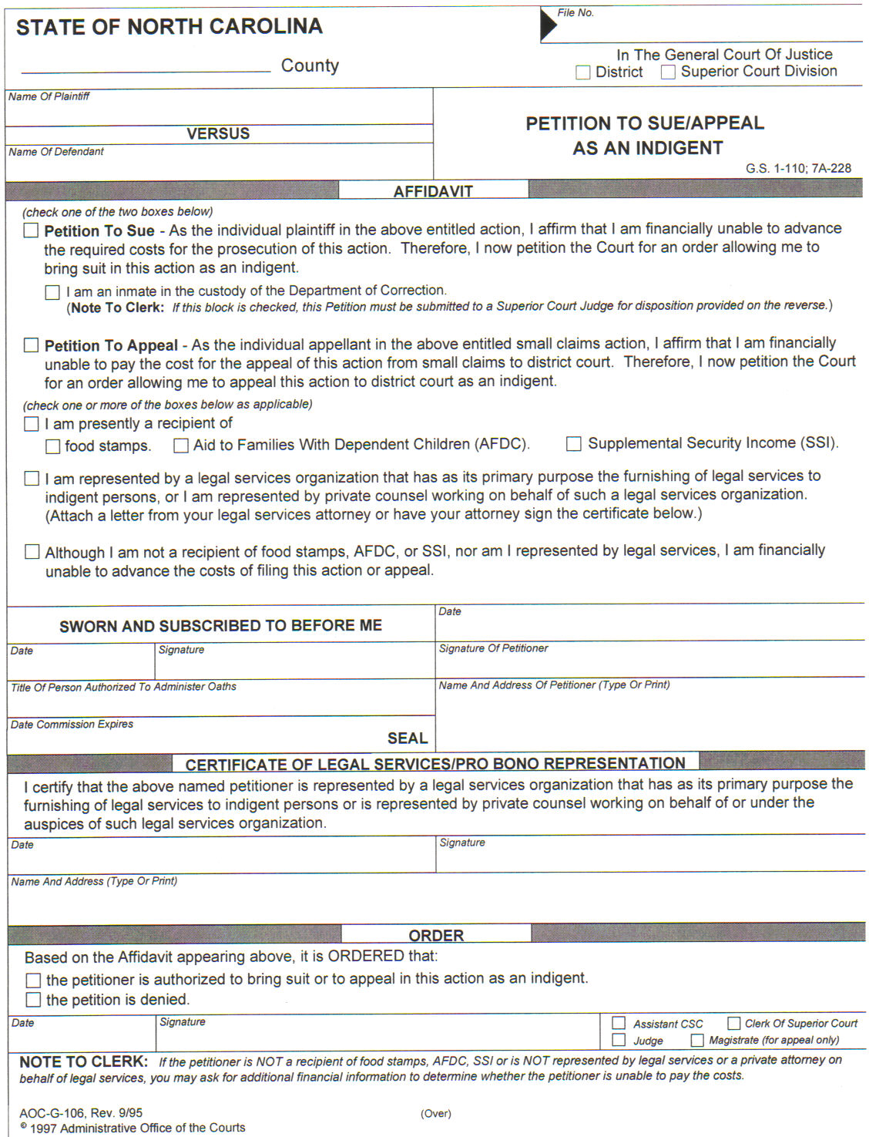
SAMPLE

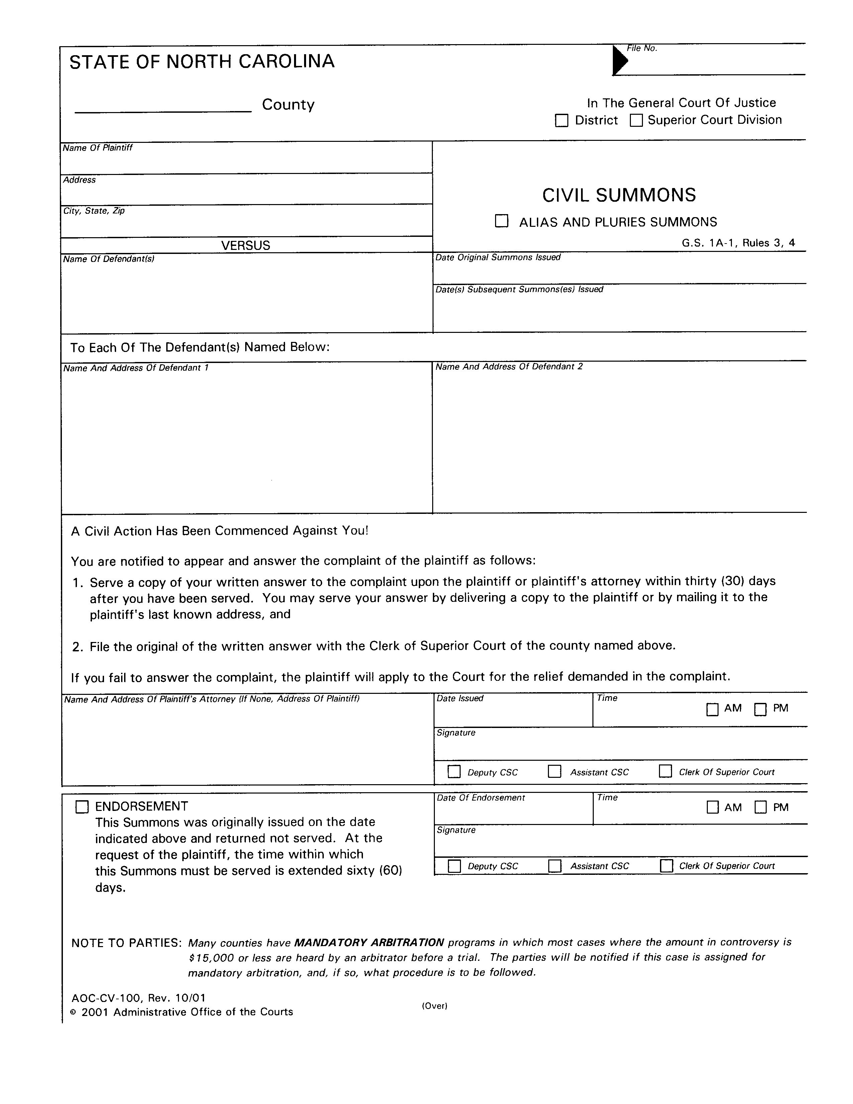
SAMPLE

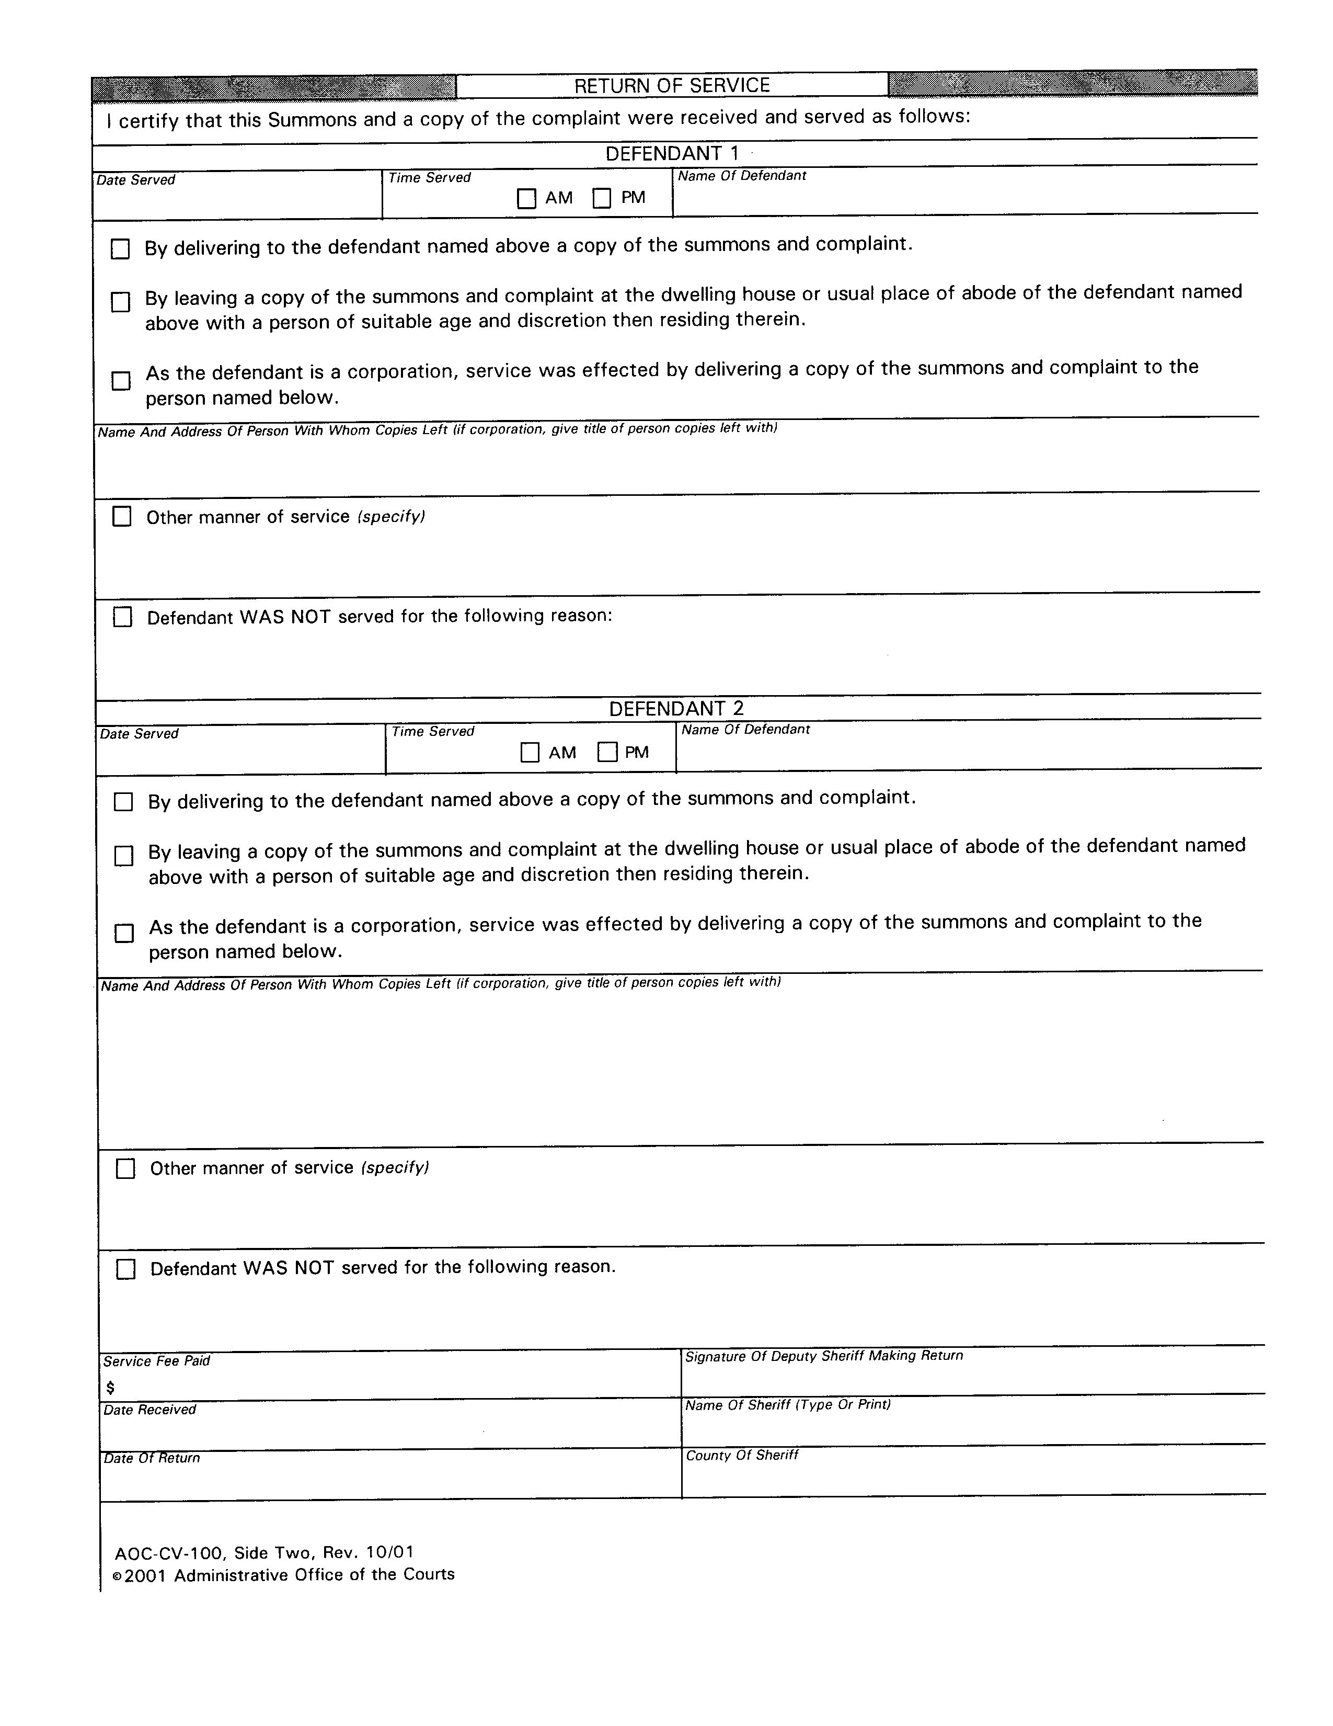
SAMPLE

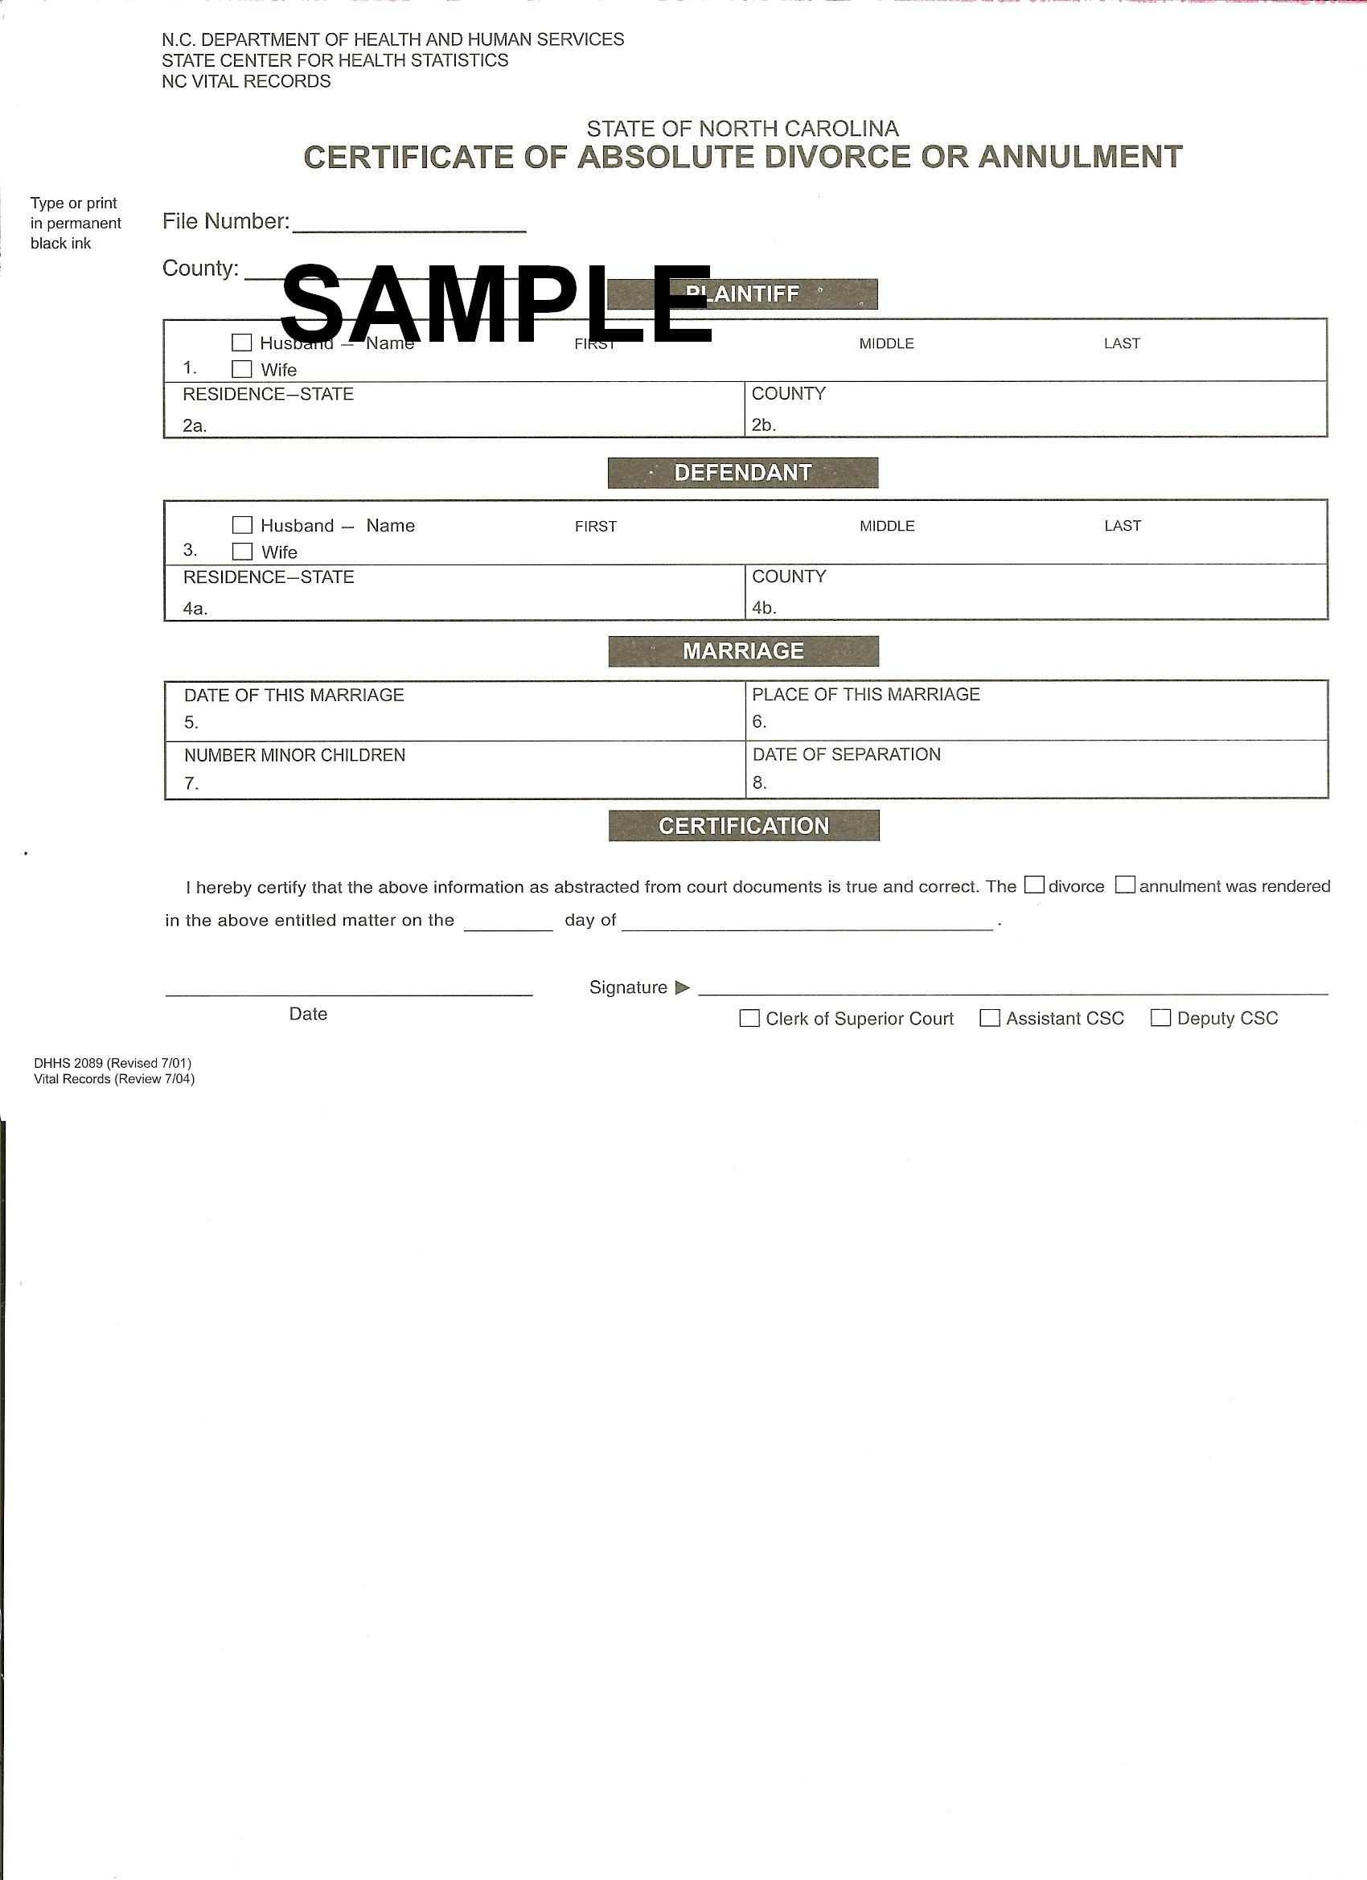
Your Name
Your Address
Date

VIA CERTIFIED MAIL

Name of Medical Provider/Hospital
Address of Hospital

RE: Notice of Separation of (YOUR NAME, DOB, LAST 4 DIGITS OF SSN) and (YOUR SPOUSE’S NAME, DOB, LAST 4 DIGITS OF SSN)

Dear Sir or Madam:

By this letter, I am putting your facility on notice that I have separated from (YOUR SPOUSE’S NAME) and have been continuously separated from him/her since (DATE OF SEPARATION). Pursuant to Forsyth Memorial Hospital v. Chisholm, 467 S.E.2d 88, I am not responsible for any bills incurred by (YOUR SPOUSE’S NAME) in the provision of services to him/her by your facility.

If you have any questions, please feel free to contact me at (YOUR PHONE NUMBER).

Sincerely,

(SIGN AND TYPE YOUR NAME)

THIS IS A SAMPLE LETTER –
USE THIS TO PUT MEDICAL PROVIDERS ON NOTICE OF YOUR SEPARATION

